- Purpose
  - The purpose of this document is to describe the procedure to properly operate the Indeva Lift Assists in the Plant 2 assembly area.

- Scope
  - This Standard Operating Procedure (SOP) applies to Manufacturing Team Members at Betco Corporation Ltd.

- Responsibilities
  - The operations manager/supervisor is responsible for enforcing this SOP.

- Materials
  - NA

- Procedure

Procedure to use the tool head in “Handle Mode” (Standard)
  - When the lift assist tool head is at rest with the E-stop activated, the display will show the word “Stop”. At this point, the tool head is locked and will not move up or down.

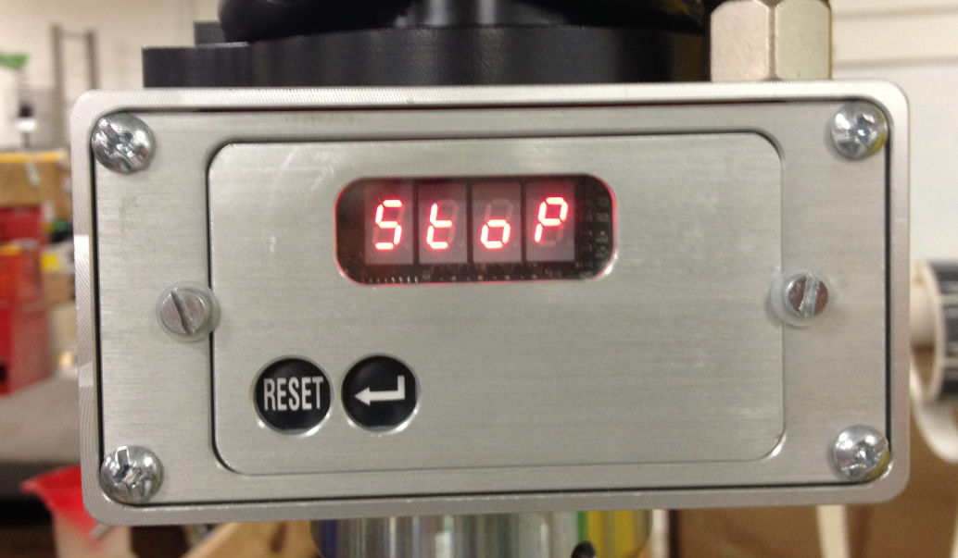

  - To use the lift assist, release the E-stop on the opposite side of the tool head by twisting it clockwise. The display will read “Abil”.

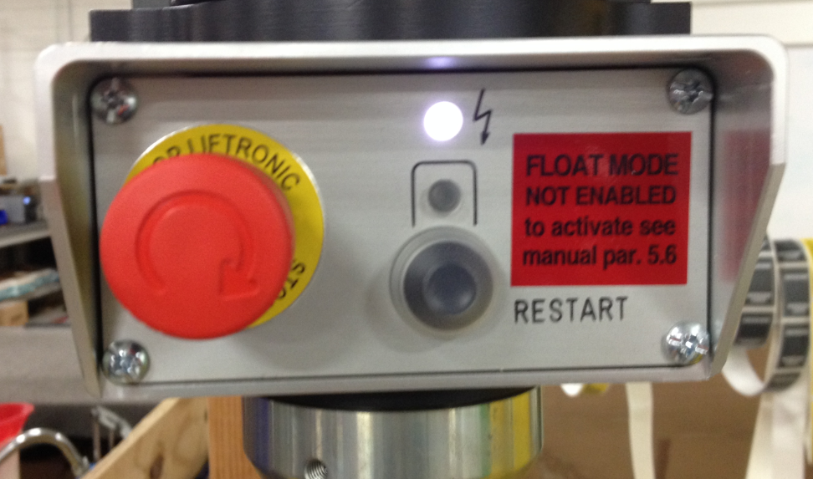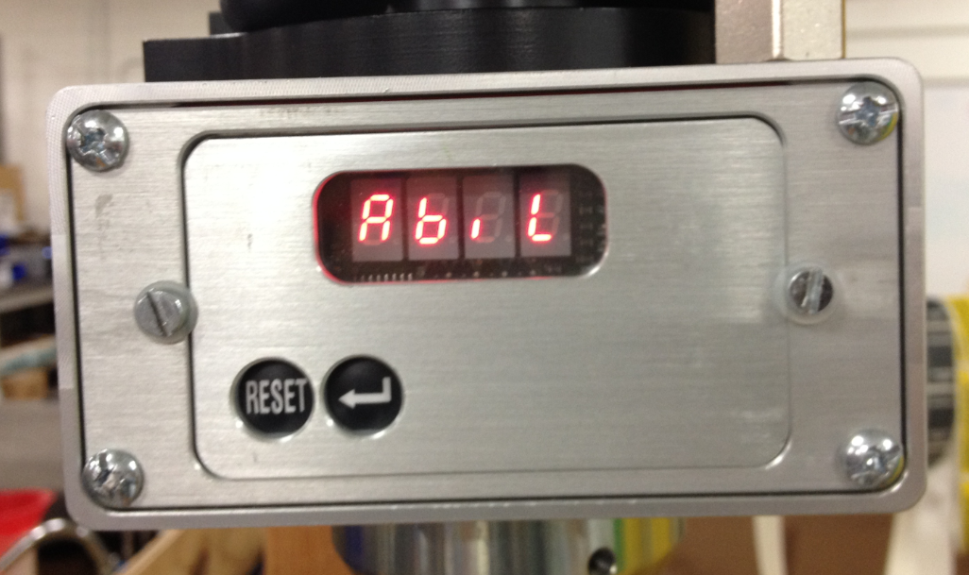
  - Keeping your hand off of the handle, press the “RESTART” button on the tool head. The display will now read “on”.

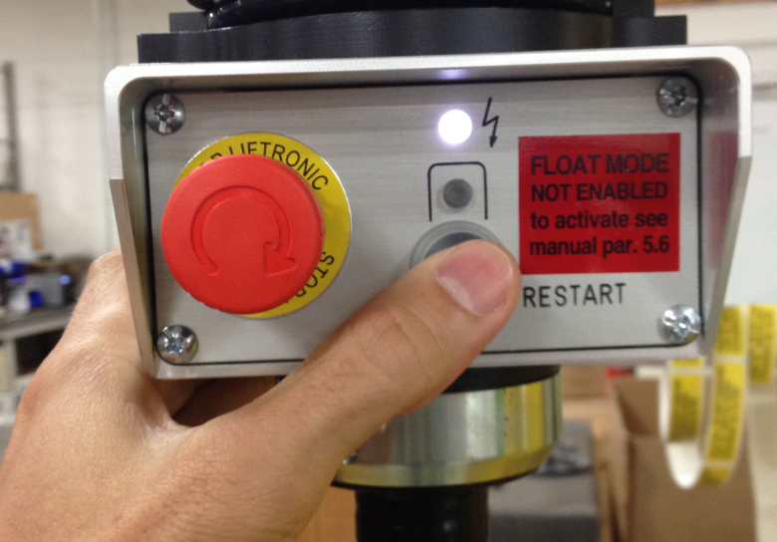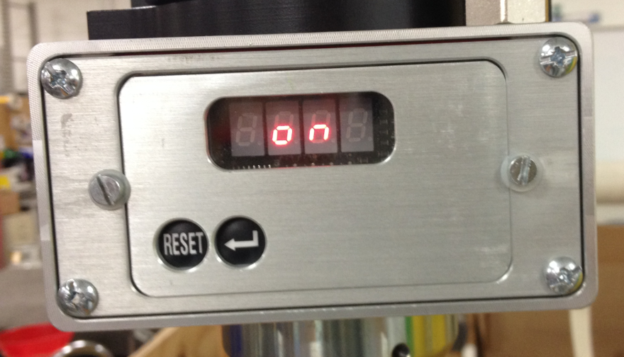

  - The tool head is now active. Grab the handle and move the tool head to the desired location. NOTE: The first move made after grabbing the handle needs to be upwards. This is a safety precaution. The tool head will only move when your hand is on the handle.

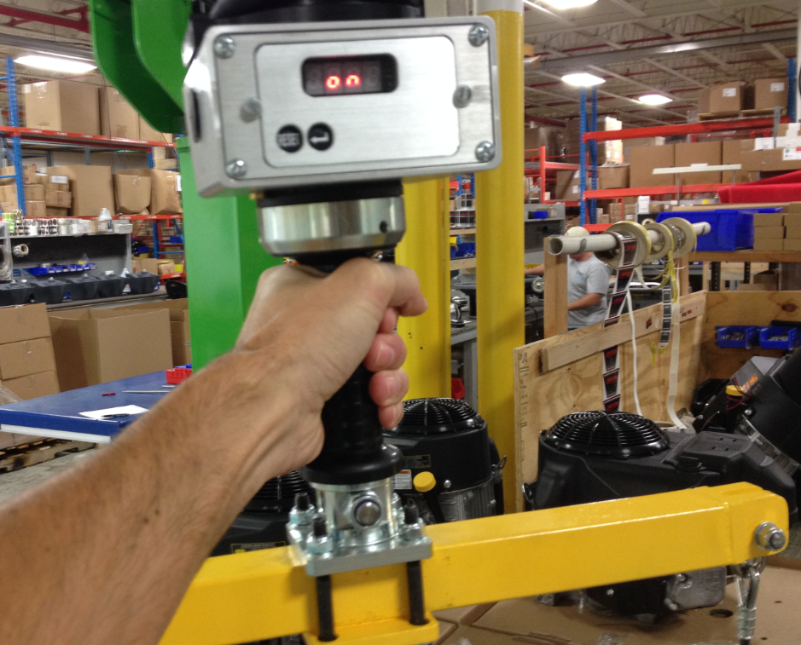

  - Hook onto the objects lifting points using the clips provided on the tool head. Grab the handle again and move the object to the desired location, set the object down and release the clips.

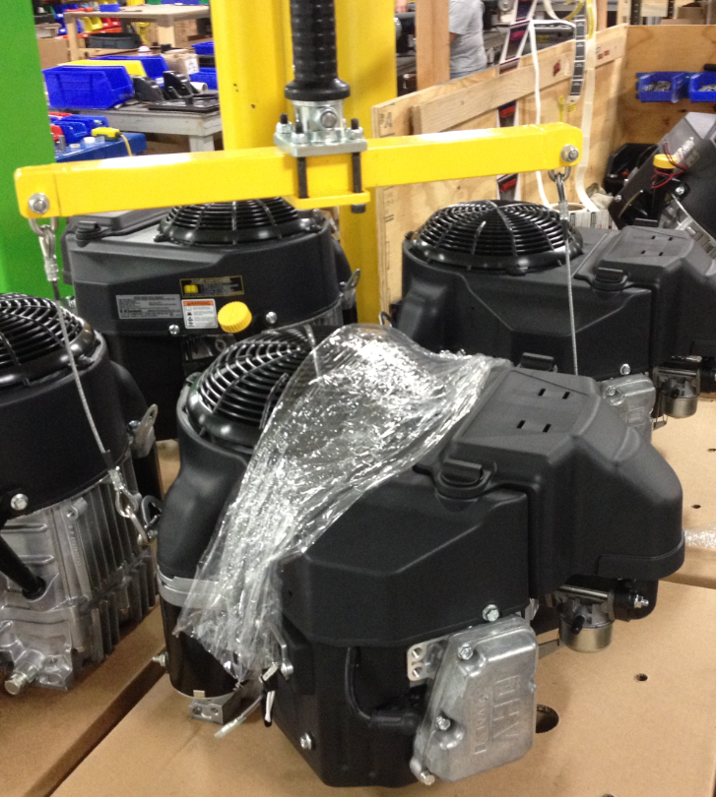
  - When not using the tool head, store it in a position that will be out of the way.
  - Push in the E-stop to lock the tool head.

Using the tool head in “Float Mode”

  - When the lift assist tool head is at rest with the E-stop activated, the display will show the word “Stop”. At this point, the tool head is locked and will not move up or down.

  - To use the lift assist, release the E-stop on the opposite side of the tool head by twisting it clockwise. The display will read “Abil”.

  - Keeping your hand off of the handle, press the “RESTART” button on the tool head. The display will now read “on”.

  - The tool head is now active. Grab the handle and move the tool head to the desired location. NOTE: The first move made after grabbing the handle needs to be upwards. This is a safety precaution. The tool head will only move when your hand is on the handle.

  - Hook onto the objects lifting points using the clips provided. Lift the object upwards so its weight is supported by the lift and release the handle.

  - If float mode is desired, press the “RESTART” button again while keeping your hand off of the handle. A green light will light up (SHOWN BELOW).

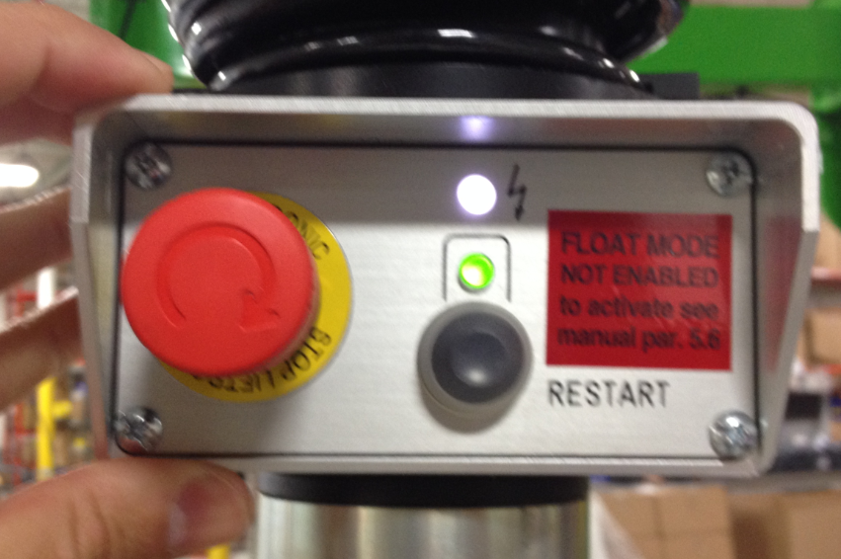
  - Float mode does not require your hand to be on the handle to move the tool head. When in float mode, you can grab the object you are lifting and move it that way. The lift assist will sense your movement and react accordingly.

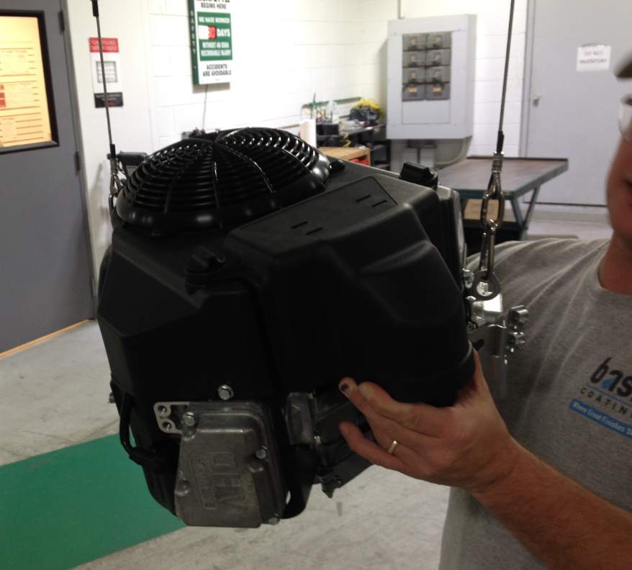

  - Move the object to the desired location, set it down, and release the clips. NOTE: Grabbing the handle at any point while in Float Mode will de-activate Float Mode. The unit will immediately go back into Handle Mode (Steps 4.01-4.09).
  - When not using the tool head, store it in a position that will be out of the way.
  - Push in the E-stop to lock the tool head.

- Training Guide

Functional Training Groups Requiring Training

- SOP Change Control

Date of Change | Reason for Change
Rev 01 - 2/14/2014 | This is the first version of the S.O.P. hence there are no revisions to this document.
Rev 02 - 1/22/2018 | Added Responsibilities Section

Approvals

Submitter/Author Approval:________________________________ Date:_____________________

Management Approval:______________________________________ Date:______________________

QAU Approval:_____________________________________________ Date:______________________

